Lab name：**OPA comparator** Student ID： B11102112 Name: Chiajui Lee

# Purpose

The purpose of the OPA comparator experiment is to help students better understand the working principles and basic characteristics of operational amplifiers. Comparators represent a special application of operational amplifiers, primarily used for comparing the magnitudes of input signals.

Through the experiment, students can observe and analyze the output behavior of comparators to comprehend their performance characteristics such as amplification factor, input impedance, and output impedance. Additionally, it helps familiarize students with the usage methods and effects of comparators in different application scenarios, while exploring performance parameters like response time and sensitivity.

The experiment enables students to grasp the fundamental principles and characteristics of operational amplifiers, including gain, input impedance, output impedance, and common-mode rejection ratio.

# Steps

1. Construct the specified circuit using operational amplifiers (OPAs) and resistors.
2. Connect +10V to the OPA's 𝑉+ terminal and -10V to its 𝑉− terminal using the power supply, while applying a 5 𝑉𝑝−𝑝 sine wave from the function generator.
3. Measure the output results using an oscilloscope.

# Data

1. Comparator
   1. Input = 5 𝑉𝑝−𝑝, 1KHz,Sin wave

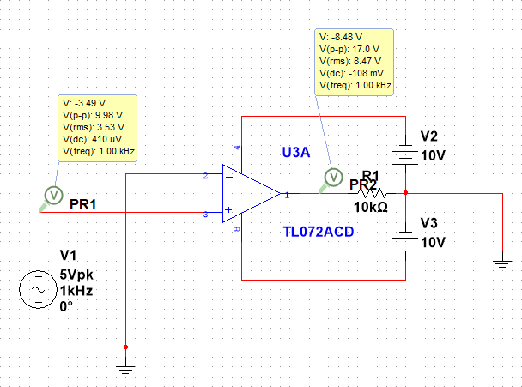

* 1. Output waveform

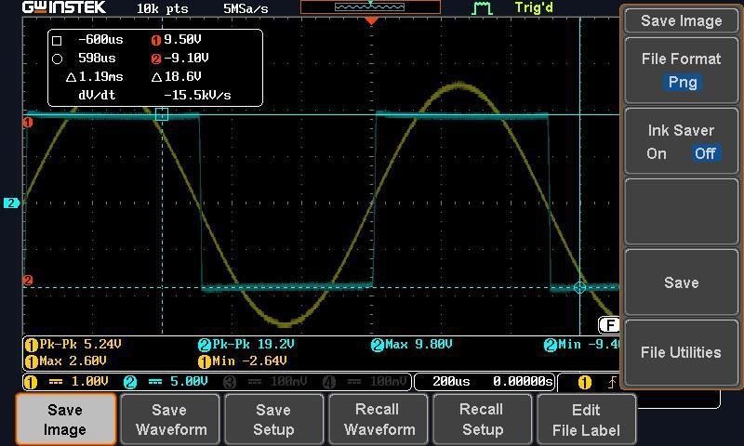

* 1. Output Voltage

|  |  |  |
| --- | --- | --- |
|  | Measured Value | Theoretical Value |
| Saturation Voltage | 9.5V、-9.1V | +-10V |

1. Schmitt Trigger Comparator
2. 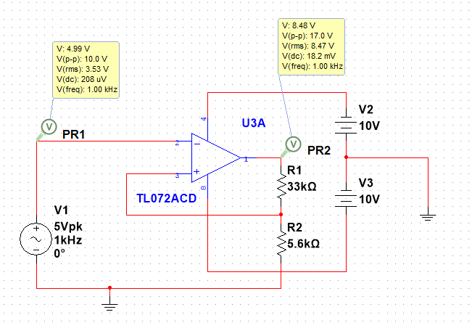Input = 5 𝑉𝑝−𝑝, 1KHz,Sin wave

a. Output Waveform

1. Output waveform

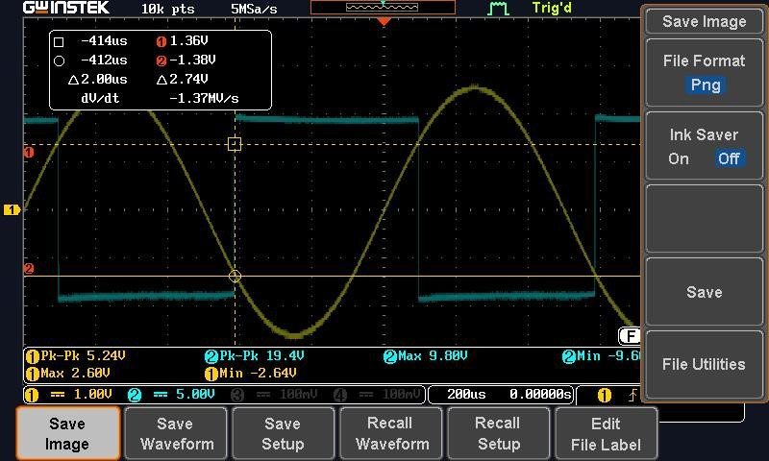

1. Output Voltage

|  |  |  |
| --- | --- | --- |
|  | Measured Value | Theoretical Value |
| Saturation Voltage | 1.36V、-1.38V | +-1.45V |

1. Comparator Applications
   * + 1. Input = 10 𝑉𝑝−𝑝, 100mHz,Sin wave

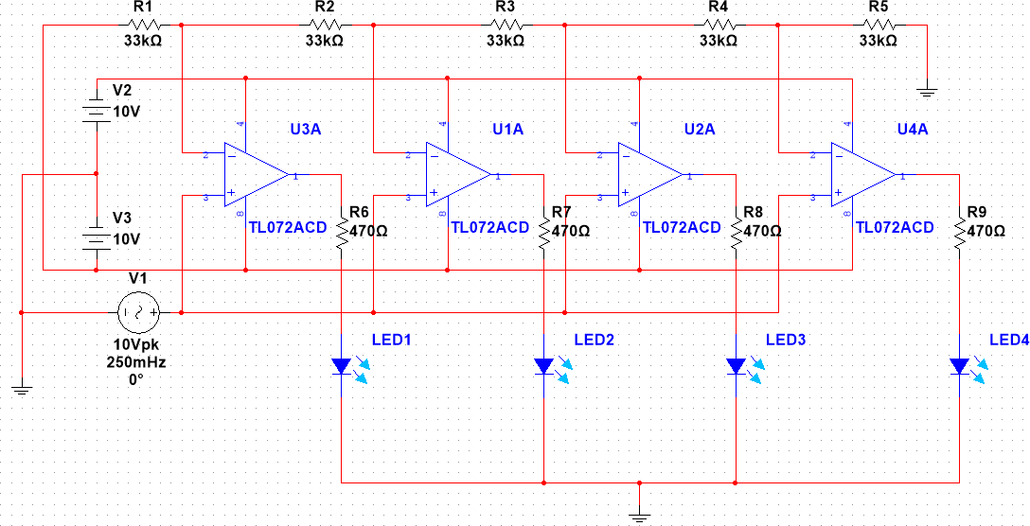

* + - 1. LED output result

1. When Vi < 2V

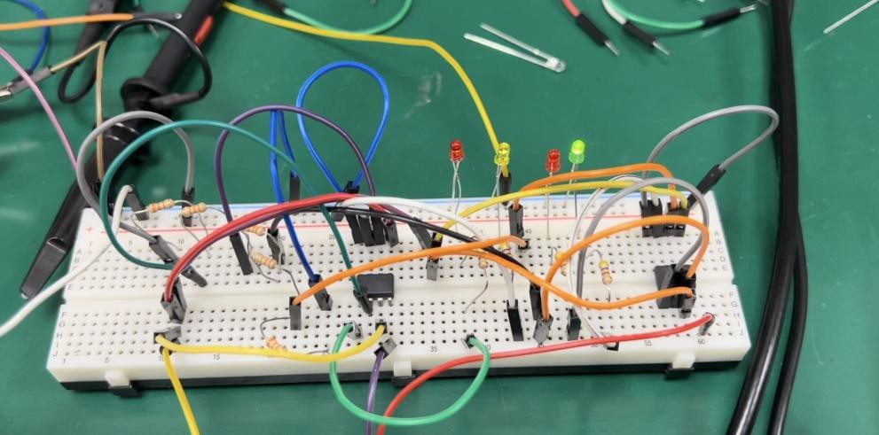

1. When 2V < Vi < 4V

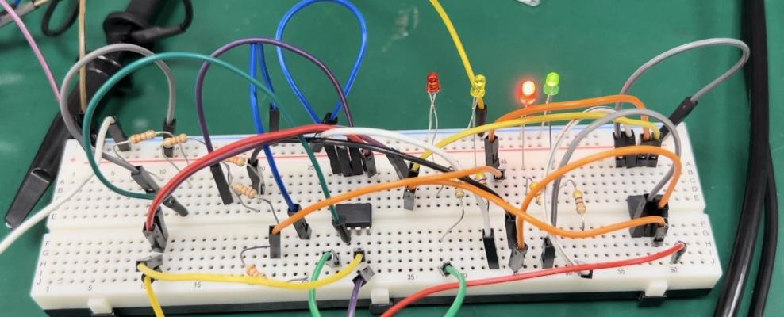

1. When 4V < Vi < 6V

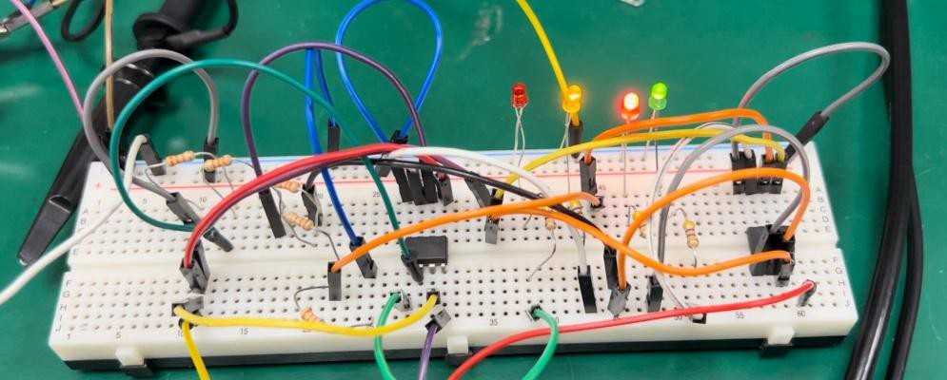

1. When 6V < Vi < 8V

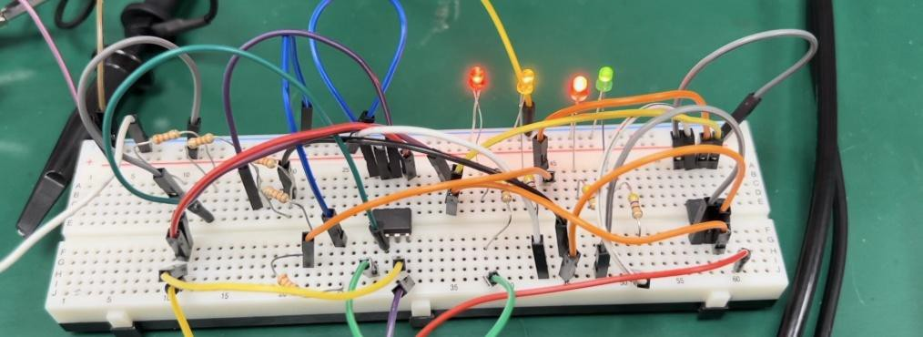

# Questions and Discussion

1. Why do the measured values of the OPA Schmitt trigger comparator sometimes exceed the actual values?

The measured values of an OPA Schmitt trigger comparator may sometimes exceed the actual values due to its hysteresis characteristics.

A Schmitt trigger comparator is a nonlinear circuit with hysteresis. When the input voltage exceeds a certain threshold, the output voltage switches to a high level; when the input voltage falls below another threshold, the output switches to a low level.

During measurement, if the input voltage rises or falls rapidly, the output of the Schmitt trigger comparator may switch (high or low) even before the input voltage actually reaches or drops below the threshold. As a result, the measured value may appear higher than the true value.

# Reflections

The main focus of this lab session was introducing the functions of an oscilloscope and the practical implementation of an OPA comparator. Learning about the oscilloscope helped me better understand some advanced features not typically covered in high school, such as measuring the saturation voltage of an OPA or determining the upper and lower threshold voltages of a Schmitt trigger comparator. These tasks require using the oscilloscope's cursor function to pinpoint specific measurement points for accurate readings.

This lab session was highly rewarding, as I gained new knowledge and skills that I believe will be valuable for my future studies and professional work.